Project Development Phase
Model Performance Test

Model Performance Testing:
S.No. | Parameter | Values | Screenshot
1. | Metrics | Classification Model:  a) Random Forest  Confusion Matrix  Accuracy Score | 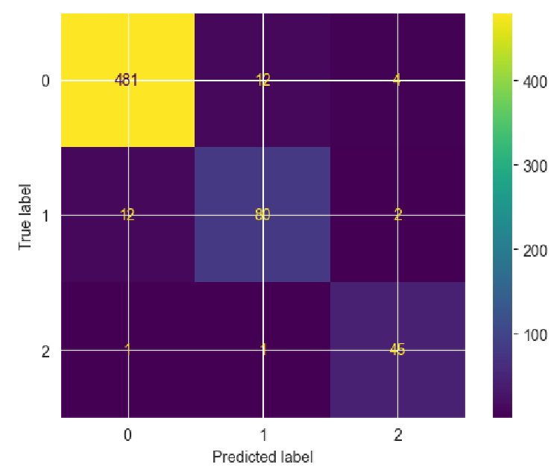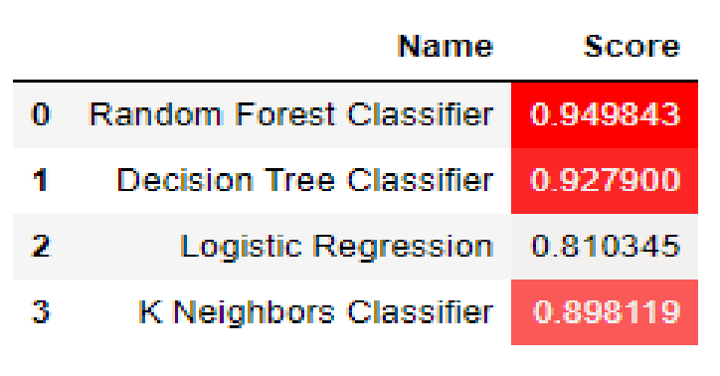

 |  | - Decision Tree  Confusion Matrix  Accuracy Score  - Logistic Regression  Confusion Matrix  Accuracy Score | 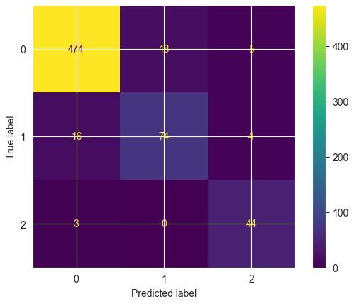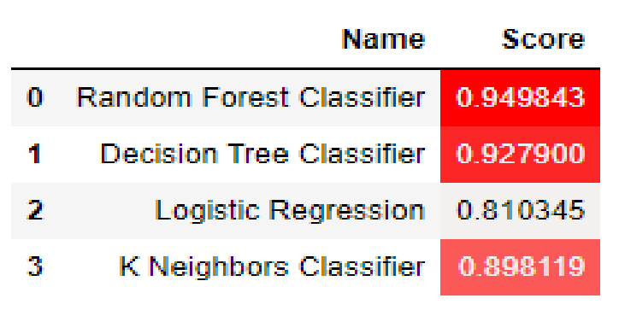  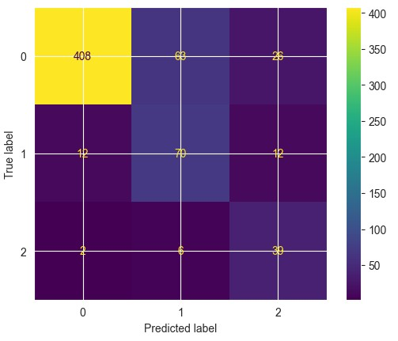  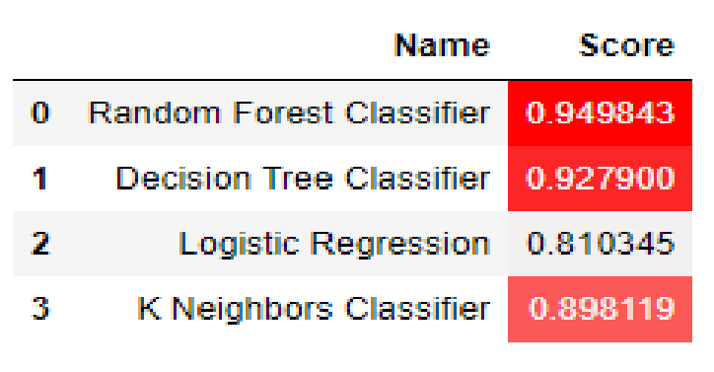
 |  | d) K-Nearest Neighbours  Confusion Matrix  Accuracy Score | 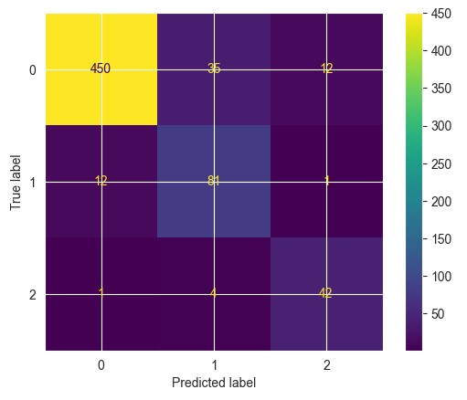  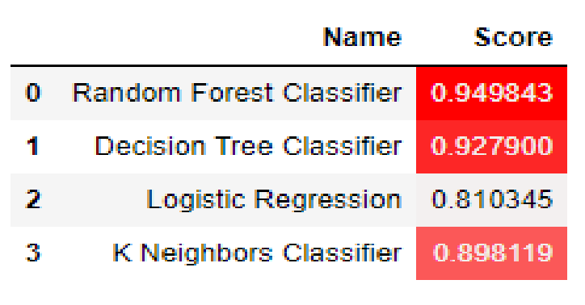
2. | Tune the Model | Validation Method | 